Practical week-1:
A local library is currently managing its books and members using a physical notebook, which has resulted in several operational problems such as misplaced books, difficulty tracking borrowed items, and inaccurate member records. To modernize its operations, the library plans to develop a database system called BookFlow. As a database developer, your task is to create the SQL foundation for this system. First, create a new database named bookflow_db. Then, design two tables: a Books table containing the columns book_id, title, isbn, and published_year, and a Members table containing the columns member_id, full_name, and email. Ensure data integrity by setting book_id and member_id as PRIMARY KEYs, applying a NOT NULL constraint to the title column so that every book must have a name, enforcing UNIQUE constraints on both isbn and email to prevent duplicate entries, and adding a CHECK constraint to ensure that the published_year is not in the future (for example, it must be less than 2027). Finally, insert three sample records into both the Books and Members tables to verify that the database structure and constraints are functioning correctly. This exercise will help you develop skills in schema definition, data integrity enforcement, and the use of SQL Data Definition Language (DDL) commands such as CREATE DATABASE, CREATE TABLE, and INSERT statements
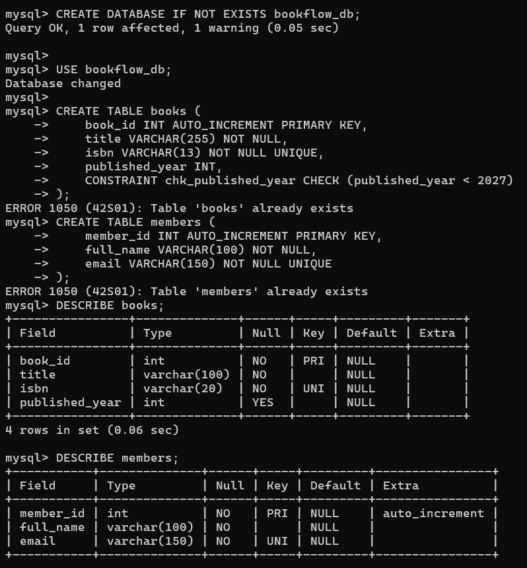

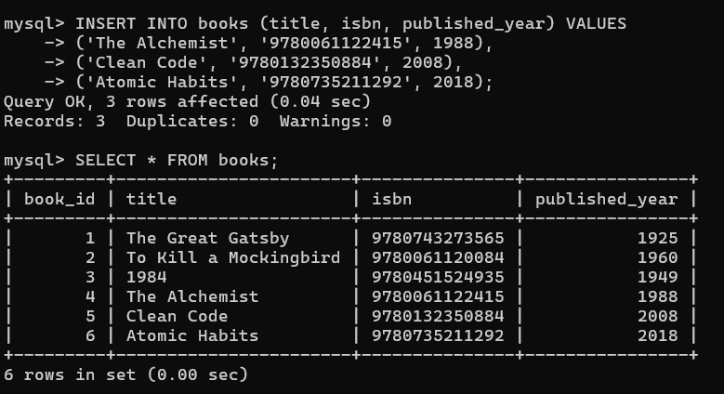

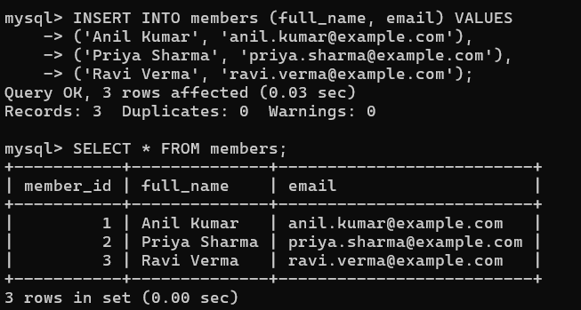
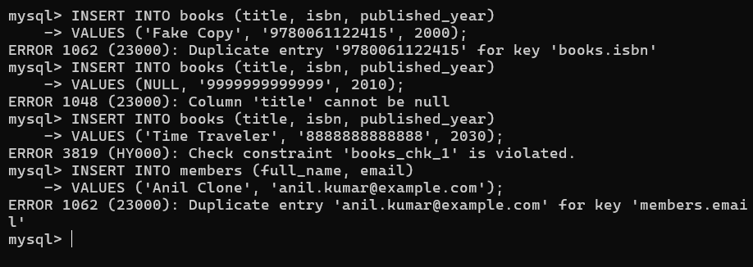

ER-Diagram:
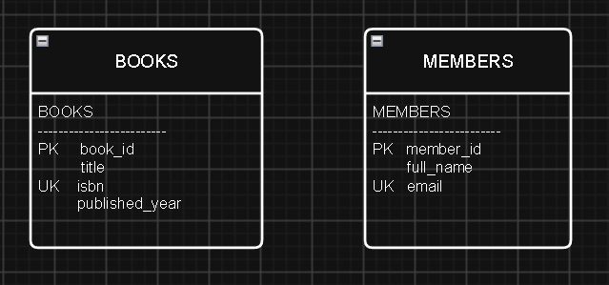
CREATE DATABASE IF NOT EXISTS bookflow_db;
USE bookflow_db;

CREATE TABLE IF NOT EXISTS books (
book_id INT PRIMARY KEY AUTO_INCREMENT,
title VARCHAR(100) NOT NULL,
isbn VARCHAR(20) NOT NULL UNIQUE,
published_year INT,
CHECK (published_year < 2027)
);

CREATE TABLE IF NOT EXISTS members (
member_id INT PRIMARY KEY AUTO_INCREMENT,
full_name VARCHAR(100) NOT NULL,
email VARCHAR(150) NOT NULL UNIQUE
);

SHOW TABLES;

DESCRIBE books;
DESCRIBE members;

SHOW CREATE TABLE books;
SHOW CREATE TABLE members;

INSERT INTO books (title, isbn, published_year)
VALUES
('The Alchemist', '9780061122415', 1988),
('Atomic Habits', '9780735211292', 2018),
('Clean Code', '9780132350884', 2008);

INSERT INTO members (full_name, email)
VALUES
('Anil Kumar', 'anil.kumar@example.com'),
('Rahul Sharma', 'rahul.sharma@example.com'),
('Priya Reddy', 'priya.reddy@example.com');

SELECT * FROM books;
SELECT * FROM members;

INSERT INTO books (title, isbn, published_year)
VALUES ('Duplicate Book', '9780061122415', 2010);

INSERT INTO books (title, isbn, published_year)
VALUES (NULL, '9999999999999', 2010);

INSERT INTO books (title, isbn, published_year)
VALUES ('Time Traveler', '8888888888888', 2030);

INSERT INTO members (full_name, email)
VALUES ('Anil Clone', 'anil.kumar@example.com');

SELECT * FROM books;
SELECT * FROM members;

SHOW TABLES;

DESCRIBE books;
DESCRIBE members;

